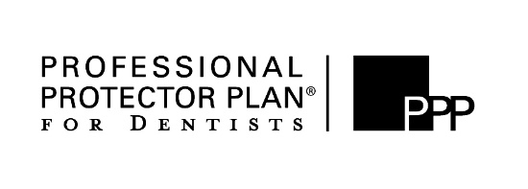
Are you interested
in a Workers’ Compensation Alternative?
Applicant Entity Name:
Mailing Address:
Federal Employers ID #: |  |  |  |  |  |  | Telephone Number:
Email Address:
List all Physical Locations:
Proposed Effective Date:
 |  |  |  |  |  |  |  |  |  |  |  |  |  | # of Employees
Workers’ Compensation Payroll Total: |  |  | Dentist & Hygienists |  |  |  |  | 8832 |  | $
 |  |  | Officers/Partners |  |  |  |  | 8832 |  | $
 |  |  | Other |  |  |  |  |  |  | $
Officers/Partners Coverage: |  |  |  |  |  |  |  | Included |  |  |  |  |  | Excluded
 |  |  | Option A |  |  | Option B |  |  | Option C
Part 2 – Employer’s Liability: |  |  | $100,000 |  |  | $500,000 |  |  | $1,000,000 |  |  | Each Accident
Please circle limits required |  |  | $500,000 |  |  | $500,000 |  |  | $1,000,000 |  |  | Disease – Policy Limit
If none circled, Option A will be offered. |  |  | $100,000 |  |  | $500,000 |  |  | $1,000,000 |  |  | Disease – Each Employee
Current Workers’ Compensation Carrier:
Current Workers’ Compensation Premium: |  |  |  |  | $
List any Workers’ Compensation claims for the past 4 years.
Complete this Quick Indication Worksheet.
Benefits of Everest / Professional Protector Plan® for Dentists Partnership
Needle Stick Reimbursement Program – Designed to pay dentists who perform tests on patients and employees when there is an accidental needle stick during patient dental treatment.
Experienced Claims Representative – All claims may be reported via phone, fax, or email, 24 hours a day, 7 days a week.
Risk Control Resources for Dental Offices – Immediate access to information, links and materials created specifically to address the risks that your dental office faces day to day.

